<http://www.abc.net.au/news/2014-12-14/wa27s-oldest-fire-tower-watcher27s-last-season/5966166?section=wa>

# Fire-tower watcher begins final season scanning West Australian horizon for bushfire

By [Mark Bennett](http://www.abc.net.au/news/mark-bennett/5896990)

Posted Sun 14 Dec 2014, 2:25pm

[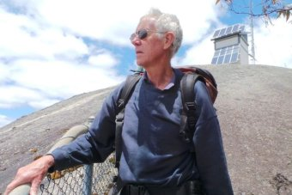**Photo:** WA's oldest and most experienced fire-tower watcher Ted Middleton is planning to hang up the binoculars. (ABC News: Mark Bennett)](http://www.abc.net.au/news/2014-12-14/ted-middleton2c-the-mt-frankland-fire-tower-manjpg/5966192)

[**Map:** Walpole 6398](http://maps.google.com/?q=-34.977,116.73(Walpole%206398)&z=5)

As Western Australia's southern bushfire season gets underway, a small group of frontline firewatchers are about to get back to work.

They will spend the summer watching for the first signs of fire.

But for the state's oldest fire-tower man, it will be his last year on guard.

Ted Middleton's daily commute takes him a little longer than it used to.

"It used to be under 10 minutes, these days it's closer to 12 as I get older," he said.

The spry 68-year-old still manages the climb of 411 metres, 20 rungs up two vertical ladders, and walking the 306 steps up to his work place at the top of Mount Frankland on the south coast of WA.

As a man used to gauging distances and measuring coordinates as a fire watcher for the Department of Parks and Wildlife, he thinks naturally in numbers.

He has a 360-degree view of 367,000 hectares of the southern forest from his three square metre lookout tower on a granite outcrop jutting above the Walpole wilderness.

Every day, starting this week, he will spend the entire summer fire season until the first rains in autumn next year, scanning the horizon for the first signs of fire.

But this year he is preparing to hand over the binoculars and the two-way microphone to a fellow fire watcher - marking the beginning of the end of the job he has done for the last 18 years.

Mr Middleton is one of a declining generation of fire watchers.

Since the 1950s there has been a network of fire lookout towers in the south west atop tall trees and steel towers.

The manned towers covered an area from the jarrah forests of the Darling Scarp down to the Mount Frankland lookout near Walpole on the south coast.

But in this age of satellites, spotter planes and remote sensing, the number of humans looking out for bushfires have dwindled, leaving fewer men like Mr Middleton guarding the vast areas of forest that stretch as far as the eye can see.

## Early warning system

Early reporting is one of the most important things in fire suppression, and he does not want to miss the first indications of trouble.

Mr Middleton is constantly scanning the horizon for the first wisps of smoke, calling up his department base in Walpole and a spotter plane to identify the problem for fire crews on the ground.

[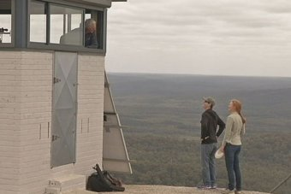](http://www.abc.net.au/news/2014-12-14/ted-middleton-firewatcher-at-mt-frankland/5966196)**[Photo:](http://www.abc.net.au/news/2014-12-14/ted-middleton-firewatcher-at-mt-frankland/5966196)** [Ted Middleton chats to climbers from his lookout atop Mount Frankland. (ABC News)](http://www.abc.net.au/news/2014-12-14/ted-middleton-firewatcher-at-mt-frankland/5966196)

On a clear day from his Mount Frankland eyrie he can see forever.

"Pretty much to Mount Barker to the East, down to the south coast, almost up to the Muir Highway to the north," he said.

"I think it's close on 70 miles and I know that Bluff Knoll in the Stirlings, that's close to 100 miles from here, and you can see that reasonably well.

"I don't know how much you'd pay a square metre for floor space in an office with a view like this."

Although it is a solitary job, he often has company.

"You get a lot of tourists, particularly over the school holidays we can get over 80 people up here in a day - there's times when you'd be happy to have a bit of a break from that," he said.

"Of course a lot of them ask questions and take an interest in what's happening so that in itself helps pass the day a bit.

"As long as you just have to make them understand that while you might be talking to them you've still got to be looking out there because that's the job that you are paid to do."

Although Mr Middleton still has his last summer ahead of him, he is already anticipating the end of an era.

"It's with mixed feelings that I'm finishing up, actually, 'cos I hadn't been able to work for quite a few years for health reasons before I started this and once I started working here I really appreciated the ability to be able to do it," he said.

When the shutters go down on the windows of his tiny lookout in March or April next year it will be a hard day for a man who loved his job.

"The last day is going to be a little bit sad, and I'll, yes I know I'm going to miss it," he said.

Gazing out across the silent forest he pauses.

"Yes, I'll miss it, I'll still come up Mount Frankland from time to time, no question about that," he said.

"Yes, I'll still come back."